Project No. | SIG-05-2025
Project Title | MRI Prostate Segmentation Assistant (MRI PSA) for Radiologist to enable seamless workflow for MRI-guided prostate biopsy
Current Project Status  (tick where appropriate) | On-going with funding (funding source ________)  On-going without funding (estimated date of completion Dec 2026)  Completed  Terminated
Date of Report | [DD] October 2026
Project Period  (Start – End Date) | 1 Oct 2025 to 30 Sep 2026
Principal Investigator (Name, Designation, Department) | Dr Tran Nguyen Tuan Anh, Consultant, Dept of Cardiothoracic & Abdominal Radiology

- Abstract of Final Report (not more than 200 words)
Provide a summary of the project: its objectives, methodology, major accomplishments and other relevant information.

Before an MRI–ultrasound fusion biopsy at SGH, a radiologist contours the prostate and marks suspicious lesions by hand in Biobot’s Urofusion software, which takes about 16 minutes per case. The contours are used once and kept only in Urofusion’s proprietary format. We set out to train an SGH-specific segmentation model, run it on the CARPL platform, and pass its output to the Biobot biopsy system. We extracted 3,477 de-identified prostate MRI studies (January 2023 to September 2025) and generated draft contours with an open-source NIH model. Ten SGH radiologists reviewed and corrected these in a custom OHIF-based viewer, completing 2,550 studies in six weeks. This annotated SGH dataset will be useful well beyond this project. With it and the public PROSTATEx data, we trained a whole-gland model (Dice 0.954 on 264 validation cases) and a lesion model (73.6% lesion sensitivity, 0.74 false positives per case). The output is standard DICOM RTSTRUCT and has been tested with Biobot’s updated Urofusion, so contours drawn in routine work can be reused for research and a future prostate cancer registry. The model is ready for deployment on CARPL and awaits AI Office approval, with trial deployment expected by December 2026.

- Background and Objectives of Project
Describe the problem statement and the objectives of the project.

Problem statement
Multiparametric MRI is now central to prostate cancer diagnosis because it allows suspicious lesions to be biopsied directly. SGH performs more than 1,700 prostate MRI examinations a year, and about 42% of these patients go on to MRI-guided targeted biopsy.
Before each targeted biopsy, the reporting radiologist contours the prostate gland and marks the suspicious lesions by hand in the vendor’s software (Urofusion, Biobot). This takes about 16 minutes per case, more than half the time needed to report the MRI itself (about 30 minutes). The contours then go through several manual steps before they reach the robotic biopsy system (Biobot Mona Lisa / UroBiopsy), which adds time and room for error.
Prostate MRI is currently the only radiology study that our radiologists routinely contour by hand in clinical work. Those annotations are used for one procedure and then sit in the vendor’s proprietary format, where they cannot be reused for research or to train AI models.
Commercial prostate MRI AI products exist, but we have not been able to adopt them. They are hard to integrate with our IT and security environment, they are expensive to run (e.g. USD 50 per study), and their output may not work with the Biobot biopsy platform. The on-premise CARPL platform, set up under the AISG-funded RAPIER project, gave us a cheaper way to deploy a model of our own.
Objectives
- Aim 1: Train an MRI prostate segmentation model on historical SGH prostate MRI, using an open-source prostate model to speed up annotation of the local data.
- Aim 2: Integrate the model with the clinical PACS through the RAPIER CARPL platform so that radiologists can use it in their normal workflow.
- Aim 3: Integrate the model’s output contours with Biobot’s targeted biopsy system.
Hypotheses
- A prostate segmentation model trained on SGH data, with help from an open-source model, can perform as well as an experienced radiologist in a fraction of the time.
- Integrating the model with the clinical and vendor systems will improve the clinical workflow. Our target was to cut contouring time from about 16 to about 5 minutes per case, saving an estimated 127 radiologist-hours a year at SGH.

- Project Progress (not more than 3 pages)
Describe the progress in relation to the original objectives of the project. Please include but not limited to:
- The prototype and its intended use,
- The methodology used to develop, test and validate the prototype,
- The study/test results,
- The overall progress in meeting the deliverables and milestones.
Feel free to include any pictures and/or videos.

1. Prototype and intended use
MRI PSA is an AI post-processing tool that drafts the prostate contour and lesion targets for MRI–ultrasound fusion biopsy. The radiologist reviews and edits the draft in Urofusion and makes the final decision (Figure 1).
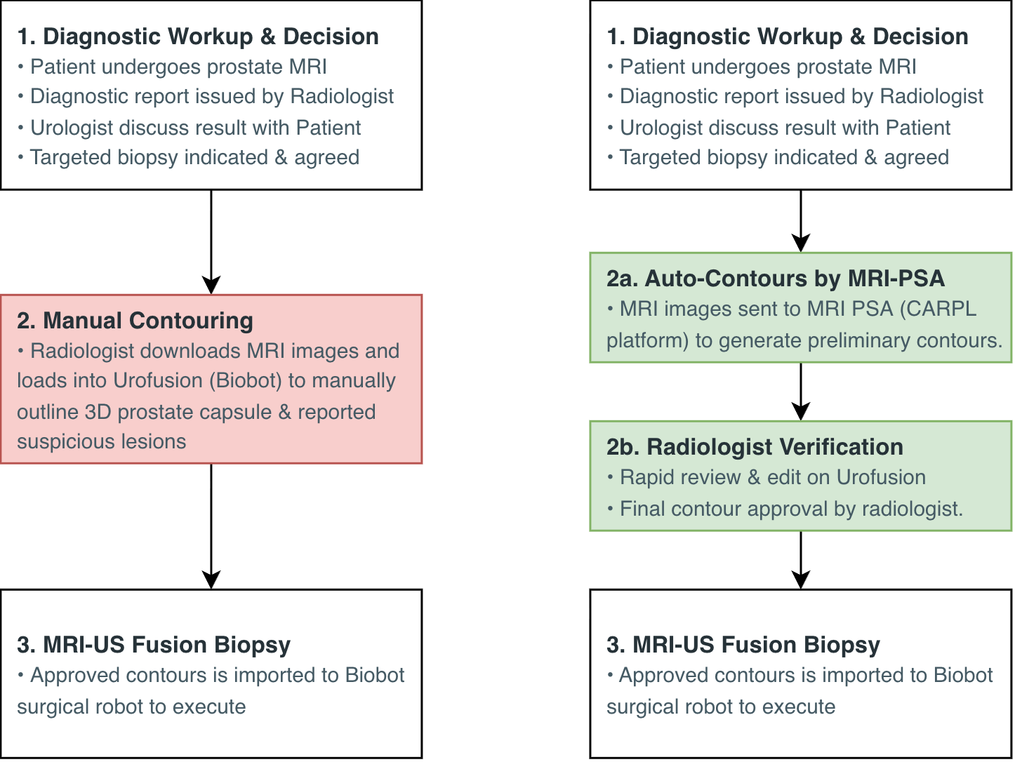
Figure 1. Biopsy planning workflow before (left) and after (right) MRI PSA.
2. Methodology
Governance. The IRB determined on 19 September 2025 that review was not required (ECOS 2025-1468). The AI Approval Form was submitted to the AI Office on 11 September 2026.
Data. TTP extracted 3,477 prostate MRI studies from SGH and its imaging centres (January 2023 to September 2025) by 13 January 2026, and the DyGCMIO research office de-identified them by 5 March 2026. The data stayed on a secure SGH drive and was not shared with third parties.
SGH data processing and model adaptation. Work on the open-source NIH model began in October 2025, but most of it could only start once the data arrived. Series naming differed across three vendors and several sites, so we built a pipeline to identify the T2W, DWI and ADC series in every study, one of the most time-consuming parts of the project. By 6 May 2026 the model produced draft contours for every study in DICOM RTSTRUCT format suitable for CARPL.
AI-assisted annotation. We built our own review application on the open-source OHIF viewer (15 May to 1 June 2026). It shows T2W, DWI and ADC side by side with the AI contours and lets the radiologist grade and correct each case (Figure 2). Ten SGH radiologists fully reviewed 2,550 studies between 1 June and 15 July 2026.
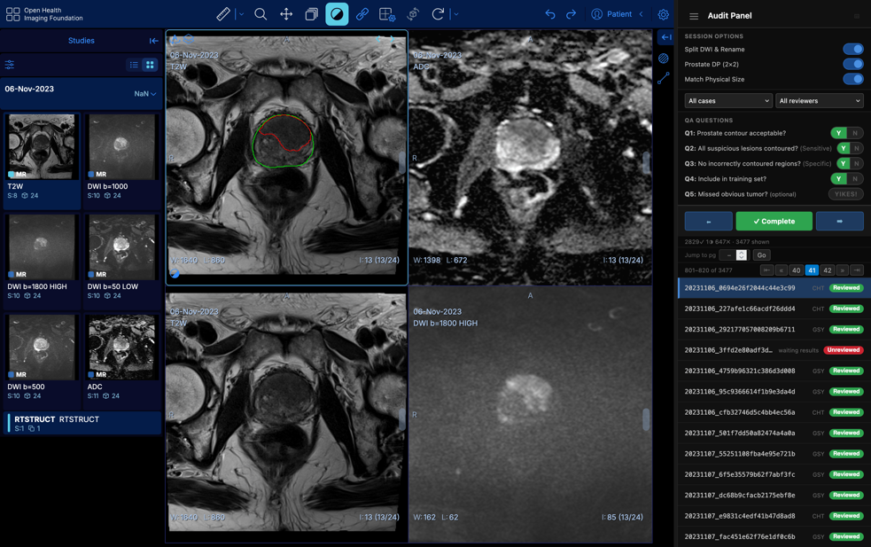
Figure 2. In-house review application (customised OHIF viewer) showing AI contours (green: prostate; red: lesion) and the audit panel used to grade each case.
Model development. After review, we trained the gland and lesion models [architecture, e.g. nnU-Net] on CHROMA using the curated SGH data and the public PROSTATEx dataset (Table 1), refining them with radiologist feedback. Training finished on 31 August 2026. The SGH scanner mix (about 65% Siemens, 20% GE, 15% Philips) matches clinical practice. A zonal (TZ/PZ) model was also trained but is not part of the planned deployment.
Model | Eligible cohort | Development design
Prostate organ segmentation | 1,751 (1,547 SGH + 204 PROSTATEx) | 1,223 training / 264 validation / 264 locked test
Lesion segmentation | 1,398 (865 SGH lesion-positive, 333 SGH radiologist-confirmed negatives, 200 PROSTATEx) | 1,189 in five-fold cross-validation / 209 locked test
Table 1. Development cohorts.
3. Results
Model | Validation basis | Dice | Other metrics
Prostate organ | 264 validation cases | 0.954 | Precision 0.952; recall 0.958
Lesion | Five-fold out-of-fold, 1,189 cases | 0.479 | Lesion sensitivity 73.6% (773/1,050); 0.74 false positives per case
Table 2. Development and validation performance.
The gland model exceeded the 90% accuracy requirement. Results on the locked test sets: [organ test Dice / lesion test sensitivity & FP per case, if available].
4. Integration and deployment
The model runs on CARPL and returns DICOM RTSTRUCT files (Figure 3). It is ready for deployment, pending AI Office approval. With Biobot, we tested and adjusted the output in the updated Urofusion until it loaded correctly (3 September 2026); cyber-security clearance to install this version clinically is pending.
[Screenshot placeholder]
Figure 3. [caption, e.g. MRI PSA output displayed on the CARPL platform]
5. Progress against milestones
Milestone | Planned | Actual | Status
Obtain IRB exemption | Oct–Nov 25 | 19 Sep 25 | Done. IRB determined review not required (ECOS 2025-1468).
Imaging data extraction | Nov 25–Jan 26 | 13 Jan 26 | Done. 3,477 studies, fewer than planned (clinical PACS load).
De-identification (by DyGCMIO) | – | 13 Jan–5 Mar 26 | Done. Started after extraction.
Onboard open-source NIH model on CARPL | Oct 25–Jan 26 | 1 Oct 25–6 May 26 | Adapted to output RTSTRUCT. Run on CHROMA, not CARPL, for annotation (Problem 4).
Process SGH data and generate draft contours | – | 5 Mar–6 May 26 | Done. Identified DICOM series across vendors and sites; could only start once data arrived (Problem 3).
Generate and refine prostate contours | Jan–Jun 26 | 15 May–15 Jul 26 | Done. Review tool built 15 May–1 Jun; 10 radiologists reviewed 2,550 studies 1 Jun–15 Jul.
Train segmentation model on SGH data | Jun–Aug 26 | 15 Jul–31 Aug 26 | Done. Started after review finished; refined with radiologist feedback.
Ensure output is compatible with Biobot software and surgical system | Jan–Aug 26 | 31 Aug–3 Sep 26 | Done after the model was built. Cyber-security clearance for clinical install started 11 Sep 26; pending.
Trial deployment of in-house model | Aug–Sep 26 | Expected by Dec 26 | Model ready for CARPL. AI Office approval submitted 11 Sep 26; expected early Oct 26.

- Project Findings and Achievements (not more than 1 page)
- Describe how the innovation could be a solution for the unmet clinical need identified.
- Describe the potential impact of the pilot data obtained in securing follow-on funding from higher-level grants or the industry, and/or licensing commitment from the industry.

Solution to the unmet clinical need
The gland model reached a Dice score of 0.954, so in most cases the radiologist should only need to check the contour and make small edits. The lesion model suggests targets for the radiologist to accept or reject. Both were trained on SGH scans with our actual scanner mix. We expect contouring time to fall from about 16 to about 5 minutes per case, roughly 127 radiologist-hours a year at SGH, and will measure this during the trial. There is no per-study fee because the model is ours; a commercial product at USD 50 per study would cost about USD 35,700 a year for our roughly 714 biopsy cases.
A large annotated SGH dataset
The most valuable output of the project is the dataset. We now have 2,550 SGH prostate MRI studies reviewed by SGH radiologists, with whole-gland and tumour annotations checked against the T2W, DWI and ADC images. It reflects our own patients, protocols and scanners, and is more than seven times the size of PROSTATEx (346 patients), the public dataset most often used for this task. It can support other prostate work, such as PI-RADS classification, lesion detection and multi-site validation.
Modernising the clinical workflow
Until now, the contours our radiologists draw for every biopsy were saved only in Urofusion’s proprietary format and used once. With MRI PSA, the draft contours are produced on CARPL in standard DICOM RTSTRUCT before they are loaded into Urofusion. Biobot will also work with us so that Urofusion can export the radiologist’s final, edited contours as RTSTRUCT. That gives us radiologist-verified ground truth for every case contoured in routine work, and lets us link each annotated tumour to the biopsy cores taken from it and to their pathology results. This is the starting point for a prostate cancer registry linking MRI, radiologist annotations, biopsy cores and final pathology, which will give us a steady supply of data to keep improving the model.
Follow-on funding and industry
We have not yet applied for a next-level grant. We want to deploy the model and set up the registry first. The PI has also unexpectedly taken over as PI of a newly funded 18-month AMII TAG project (September 2026 to February 2028) after the original PI left SGH. We will consider a cluster or national application (e.g. NMRC or NHIC) once the registry is running.
Biobot contributed SGD 107,050 in kind (staff time and software), against a target of SGD 25,000. Licensing talks are at an early stage. Because Biobot is a commercial company, licensing would need our model to be ISO certified and HSA registered, which would take considerable further work and funding. Other SingHealth hospitals that use the Biobot system could adopt the same workflow, and because CARPL shares its architecture with AIM.SG, there is a path to national use.

- Problems Encountered
Highlight any problems encountered and describe how they were resolved. If not resolved, please provide any recommendations on how to circumvent such problems in the future.

Most steps could only start once the previous one had finished: IRB outcome, extraction, de-identification, annotation, training and AI Office review. Early delays therefore pushed back later steps, and deployment is being completed after the grant period.
1. Data extraction was slow and yielded fewer studies. The clinical PACS was under heavy load, so extraction took TTP much more effort than planned. We stopped at 3,477 studies, enough to develop the models, and extraction finished on 13 January 2026. Meanwhile we built the data pipeline and trained a first model on open-source data.
Recommendation: The institution should improve the data access workflow for data-intensive projects like this one.
2. De-identification was more complex than expected. We needed unneeded image series removed, which Imaging Informatics could not do. The DyGCMIO research office, which only takes complex datasets, did it free of charge and finished on 5 March 2026, about two months later than planned. Imaging Informatics charges because it has no funded headcount for de-identification, and which group can take a dataset is only known after extraction.
Recommendation: Expand Imaging Informatics’ capacity and keep a funded position there for research de-identification.
3. Processing the SGH data took substantial effort. Series were named inconsistently across three vendors and several sites, so we had to work out which series in each study was T2W, DWI or ADC before the model could run. This could only start when the data arrived on 5 March and took until 6 May 2026. We built a configurable pipeline for all three vendors and checked its output against the images.
Recommendation: Keep the sequence mapping up to date when protocols or scanners change.
4. Too little time to use CARPL for annotation. We had planned for radiologists to review the draft contours in the CARPL viewer. Onboarding means setting up and testing the whole chain with the CARPL team (data import, inference, RTSTRUCT display), and the late data left too little time for that. To protect time for annotation, training and the technical requirements (DICOM output conformance, compatibility with Urofusion), we pivoted: we ran inference on CHROMA at no cost and built our own OHIF-based review application between 15 May and 1 June 2026. This was development work we had not planned for.
Recommendation: Allow enough time to work with the platform vendor on onboarding and end-to-end testing. Future annotation projects can reuse our review application.
5. Urofusion integration is not finished. The Urofusion version in clinical use cannot read RTSTRUCT. We finished testing our output with Biobot’s updated version on 3 September 2026. Cyber-security clearance to install it clinically started on 11 September and is pending: screening flagged Biobot’s latest submission for a virus, a false positive, and Biobot is resubmitting.
Recommendation: Allow time for vendor software to clear cyber-security screening, including resubmission.
6. AI Office approval is still pending. The model is ready for CARPL deployment. We submitted the form on 11 September 2026, after training was complete. Approval has been delayed for administrative reasons and is expected in early October 2026.
Recommendation: The review needs final model results, so leave enough time between the end of training and deployment.

- Deviations from Original Proposal
Highlight deviations, if any, from the aims and/or methodology in the original project proposal and provide justifications for the deviation(s).

1. Fewer studies, from a more recent period. We used 3,477 studies from January 2023 to September 2025 instead of about 5,000 from 2018 to 2024. As noted in the interim report, the clinical PACS was under heavy load, so extraction was slow and yielded fewer studies. We stopped extraction to keep to schedule. The dataset was still large enough for the gland model to exceed the 90% accuracy target.
2. Draft contours generated and reviewed outside CARPL. We ran the NIH model on CHROMA and reviewed its output in our own OHIF-based application instead of the CARPL viewer (Problem 4). This avoided inference fees but took development time we had not planned.
3. Public data added. We added the public PROSTATEx dataset to the SGH data, and trained an early model on open-source data while waiting for extraction.
4. Lesion model added. The proposal covered gland segmentation and listed tumour detection as future work. The annotated data made a lesion model possible, so we built one to suggest biopsy targets. We also trained a zonal (TZ/PZ) model, but it is not part of the planned deployment.
5. De-identification provider. De-identification was done by the DyGCMIO research office rather than TTP (Problem 2).
6. Timeline. Trial deployment, planned for August to September 2026, will take place after the grant ends. It is waiting on AI Office approval (expected early October 2026). The model is ready for CARPL deployment, and cyber-security clearance for the updated Urofusion is in progress. We expect to start by December 2026, without further funding.

- Justification for Underutilisation of Budget (<70%)

We spent SGD 27,900 of the SGD 50,000 awarded (55.8%). The underspend came from savings and from institutional resources we could use free of charge, not from dropping any of the project aims.
Item | Budgeted (SGD) | Actual (SGD) | Reason for variance
Data Science analyst (0.1 FTE) | 15,000 | 15,000 | As budgeted.
IRB exemption review | 2,700 | 800 | We applied for exemption and the IRB determined review was not required (19 Sep 2025); SGD 800 was charged.
Data extraction by TTP | 11,200 | 11,200 | As budgeted. Fewer studies were extracted (3,477), but each took more TTP effort because of clinical PACS load.
Data anonymisation by TTP | 11,200 | 0 | Imaging Informatics could not handle the complex de-identification (removing unneeded images). The DyGCMIO research office did it free of charge.
CARPL inference for preliminary masks | 9,900 | 900 | The delayed extraction left too little time to onboard the open-source model onto CARPL (Problem 4). About 500 studies were processed on CARPL and the rest free of charge on CHROMA, reviewed in an application we built.
Total | 50,000 | 27,900 | 55.8% utilised
The cash figure understates the effort that went into the project. The team built the inference pipeline and review application without extra funding, 10 radiologists gave their time to review 2,550 studies, and Biobot contributed SGD 107,050 in kind.

- Outcomes and Future Plans
Give a brief description of the outcomes and future plans resulting from this project.
- By December 2026: obtain AI Office approval, deploy the model on CARPL, get cyber-security clearance for the updated Urofusion once Biobot resubmits it, and start trial deployment in the Department of Diagnostic Radiology.
- During the trial, validate the model prospectively on CARPL. We will measure contouring time with and without MRI PSA, record how often radiologists accept or edit its contours, and use their feedback to refine the model.
- Work with Biobot to export radiologist-edited contours from Urofusion as RTSTRUCT, and use this to set up a prostate cancer registry linking MRI, radiologist annotations, biopsy cores and final pathology. Cases contoured in routine work will feed the registry and give us data to improve the model and extend it, for example to PI-RADS classification.
- Reuse the annotated SGH dataset for further prostate imaging work.
- Offer the workflow to other SingHealth hospitals that use the Biobot system, and look at deployment through AIM.SG.
- Consider a cluster or national grant (e.g. NMRC or NHIC) once the registry is running.
- Submit the technical disclosure, which is being prepared, and continue early talks with Biobot. Licensing would first need ISO certification and HSA registration of the model, which will require separate funding.

Indicators | Target | Achieved | Details of achieved outcomes
Intellectual Capital  Please specify the number of technical disclosures submitted/ to be submitted. | 1 | 1 (in preparation) | - Date of submission(s): In preparation [expected date]  - Reference no(s).: Pending
Future Grants  Please specify which grants (Cluster/ National/ International) you intend to apply/ have applied for. | 1 | 0 (planned) | - Funding Body: To be identified (e.g. NMRC / NHIC)  - Grant ID: NA  - Project Title: NA  - Name of PI: NA  - Grant Amount: NA  - Grant Period: NA  Not yet applied. We plan to deploy the model and set up the registry first, and the PI has taken over a newly funded AMII TAG project (18 months from Sep 2026). We will consider an application after that.
Industry Relevance  Please specify the funding/spending secured and/or licensing commitment from the industry. | SGD 25,000 (in-kind) | SGD 107,050 (in-kind) | - Names of organization(s): Biobot Surgical  - Amount of funding/spending (cash): Nil  - Amount of spending (in-kind): SGD 107,050 (Biobot staff time and updated Urofusion software that reads RTSTRUCT)  - Number of licenses: 0. Talks are at an early stage; licensing would need ISO certification and HSA registration of the model.
Others  Please specify (e.g. spin-offs). | NA | See details | Annotated SGH prostate MRI dataset of 2,550 studies reviewed by SGH radiologists; OHIF-based review application; RTSTRUCT workflow that makes routine clinical contours reusable. No publications or conference presentations yet.

- Signing of Report
This report must be signed and dated by the PI of the project and countersigned by the Head of Department.
*Please note that you will be required to update Research & Innovation Office on the project status and report on the outcomes that have resulted from this project on a yearly basis.

PI Signature, Name, Designation  Date: |  | HOD Signature, Name  Date:

